A PROJECT REPORT

ON

## “AWARENESS, PREDICTION AND DETECTION OF FRAUD”

SUBMITTED TO THE PAH SOLAPUR UNIVERSITY, SOLAPUR IN PARTIAL FULFILMENT OF THE REQUIREMENTS FOR THE AWARD OF

### B. TECH IN

**COMPUTER SCIENCE AND ENGINEERING**

SUBMITTED BY

1. JAMADAR SAHIL RAJJAK PRN NO. 202101007018471
2. CHOUDHARI RUSHIKESH NAVNATH PRN NO. 202201007044537
3. PAWAR ROHIT TANAJI PRN NO. 202101007018464
4. MAHAMUNI PIYUSH SHRINIWAS PRN NO. 202101007018520
5. CHINTAMAN SHIVAM MADHAV PRN NO. 202101007018461

UNDER THE GUIDENCE OF

### PROF . SRUSHTI RAUT



**DEPARTMENT OF COMPUTER SCIENCE AND ENGINEERING MIT COLLEGE OF RAILWAY ENGINEERING & RESEARCH, BARSHI – 413 401**

**2024-25**

AFFILATED TO

PAH SOLAPUR UNIVERSITY, SOLAPUR



## CERTIFICATE

This is to certify that Project report entitled.

## “AWARENESS, PREDICTION AND DETECTION OF FRAUD”

Submitted by

**Jamadar Sahil Rajjak PRN No. 202101007018471**

is bonafide work carried out under the supervision of **Prof. Srushti Raut** by above student and it is submitted towards the fulfilment of the requirement of PAH Solapur University, Solapur for the award of the degree of Bachelor of Technology (Computer Science and Engineering) during academic year 2024-25.

Prof . Srushti Raut Prof. Sushma Mule

Project Guide Project Coordinator

Prof. S.S.Mule Dr. M.J. Lengare

H.O.D Principal

External Examiner Name and Sign Place: Solapur

Date: / /

### DECLARATION

We undersigned hereby declare that the Report for final year B.Tech. CSE Dissertation entitled is “**AWARENESS, PREDICTION AND DETECTION OF FRAUD**” is

done under the guidance of **Prof. Srushti Raut**. We are declaring that this dissertation work is carried out by our team and it is original. We have not copied any material, which are useful to work or other report that is submitted to the PAH Solapur University, Solapur.

Yours faithfully,

###### Jamadar Sahil Rajjak

Place: Barshi Date: / /

### ACKNOWLEDGEMENT

We feel profound happiness in forwarding this dissertation report as an image of sincere efforts. The successful dissertation reflects our work effort of our guide in giving me good information

Our sincere thanks to our guide respected **Prof. Srushti Raut**. We give our special thanks to respected **Prof.Sushma Mule,** Project Coordinator for giving us her valuable support and cooperation to enable us to complete our project successfully.

**Prof. S.S.Mule** H.O.D CSE Department who has been a constant source of information and guiding star in achieving my goal & for giving valuable guidelines for completing this dissertation.

We express our deep sense of gratitude to **Dr.M.J.Lengare** our Principal his constant interest and encouragement throughout the completion of our project.

Goal makes us to do work. Vision is more important than goal which makes us to do work in the best way to make work equally the best. We thank to all CSE department staff members for their support and guidance.

We are also thankful to my parents and friends for their extended support and valuable guidance.

**Jamadar Sahil Rajjak**

### ABSTRACT

In today's digital age, financial fraud, particularly credit card fraud, poses a significant threat to consumers and businesses alike. Our project focuses on creating a **comprehensive web based platform** aimed at both **raising awareness about different types of financial frauds** and providing **fraud detection** using advanced machine learning algorithms. The website serves two primary purposes: educating users about various types of financial fraud and detecting credit card frauds through an AI-powered fraud detection model.

The **awareness section** of the platform covers a wide range of fraud schemes, including phishing attacks, identity theft, online payment fraud, and credit card fraud, providing users with educational resources on how to protect themselves. Users can explore various fraud types and gain insights on prevention techniques, best practices, and common fraud patterns in online transactions.

For fraud detection, the platform integrates a **machine learning model**, primarily focused on detecting **credit card frauds**. The model uses a dataset of past transactions and implements algorithms like **Logistic Regression**, **Random Forest**, and **Support Vector Machines (SVM)** to classify transactions as either fraudulent or non-fraudulent. These algorithms analyze features such as transaction amount, location, timing, and other behavioral data to predict the likelihood of fraudulent activity. The **Principal Component Analysis (PCA)** technique is applied to reduce the dimensionality of the data, ensuring that the model runs efficiently while maintaining high accuracy.

The **website** is developed using modern web technologies to ensure ease of use and accessibility. It allows users to input transaction data and receive fraud predictions, empowering users to identify suspicious activities in . The user-friendly interface enables seamless interaction, making fraud detection both educational and practical for individuals and businesses.

In summary, this project combines **fraud awareness** with **fraud detection** using machine learning, helping users stay informed about potential threats while providing them with actionable tools to detect and prevent financial fraud. This integrated approach aims to enhance the security of online transactions and foster a safer digital financial environment.

# CONTENT

1: INTRODUCTION 1

2: LITERATURE REVIEW 5

3: REQUIREMENTS ANALYSI

1. Software Requirements 7
2. Hardware Requirements 7

4: PROBLEM STATEMENT

* 1. Problem Statement 8
  2. Objective 8
  3. Scope 9

5: SYSTEM DESIGN

* 1. Flowchart Diagram 10
  2. Sequence Diagram 10
  3. Use Case Diagram 11
  4. ActivityDiagram 11
  5. Class Diagram 12
  6. State Chart Diagram 12
  7. Component Diagram 13
  8. Deployment Diagram 13

6: IMPLEMENTATION DETAILS 14

7: RESULT AND ANALYSIS 15

1. CONCLUSION AND FUTURE SCOPE 21
   1. Appendix : List Of Abbreviation 24
   2. Appendix : List of Publication 25
   3. References 29

## 1: INTRODUCTION

#### 1.1 General Introduction

With the rapid growth of online transactions and digital payments, financial fraud, particularly credit card fraud, has emerged as a critical issue affecting individuals and businesses. Fraudulent transactions can lead to severe financial losses and erode trust in online financial systems. In response to this growing threat, our project aims to develop a web-based platform that focuses on both raising awareness about various types of financial fraud and providing an advanced machine learning-based solution to detect credit card fraud in .

The platform is designed with two core objectives:

1. **Spreading Awareness :** Educating users about different types of financial frauds, including phishing, identity theft, online payment fraud, and credit card fraud. The website provides informative resources and preventive measures, helping users recognize and avoid common fraud tactics.
2. **Fraud Detection:** Leveraging machine learning algorithms such as Logistic Regression, Random Forest, and Support Vector Machines (SVM) to analyze transaction patterns and detect fraudulent activity. The model primarily focuses on credit card fraud detection, identifying anomalies in transaction data to flag suspicious transactions.

In today's interconnected world, where digital payments are becoming the norm, it is crucial to provide users with tools to understand and combat fraudulent activities. This platform not only offers educational content on fraud prevention but also incorporates a sophisticated fraud detection system to enhance online transaction security. By integrating fraud awareness with detection, the project aims to create a safer digital environment, reducing the risk of fraud and protecting financial integrity.

Credit Card Fraud Detection Using Machine Learning: The second key objective of the platform is to provide a fraud detection system that utilizes cutting-edge machine learning (ML) algorithms to identify potential fraudulent transactions. The system primarily focuses on credit card fraud detection but can be extended to other forms of transactional fraud in the future. The detection model works by analyzing patterns in transaction data and flagging suspicious activities that deviate from normal behavior.

**MITCORER, BARSHI 1 |** P a g e

With the explosive expansion of online transactions, mobile banking, and digital wallets in recent years, financial fraud—especially credit card fraud—has emerged as a widespread and pressing concern that affects not just individuals but entire organizations and financial institutions. The increased adoption of cashless payment systems has brought convenience, but it has also introduced vulnerabilities that fraudsters exploit. Credit card fraud, in particular, can result in unauthorized purchases, identity theft, and massive monetary losses, shaking customer confidence and tarnishing the reputations of banks and e-commerce platforms alike.

Recognizing the urgency and impact of these issues, our project proposes a comprehensive web-based solution that addresses both **fraud awareness** and **fraud detection**. The project’s dual-pronged objective is to educate users about the various types of online financial frauds while simultaneously equipping them with a robust detection system powered by modern machine learning (ML) techniques.

In the current era of interconnected digital platforms, where millions of transactions occur per second, tools that enable both fraud awareness and automated detection are essential. The fusion of user education with machine learning provides a more holistic approach to tackling financial fraud. Users benefit not only from enhanced protection but also from understanding the risks they face in the digital economy. Furthermore, the detection system is flexible enough to accept CSV files of varying formats, allowing financial institutions or analysts to plug in their transaction data for instant analysis.

This project sets the stage for scalable fraud protection mechanisms that can be deployed across industries. It aims not only to detect credit card fraud efficiently but also to serve as a foundational framework that can be extended to detect other types of cyber and transactional frauds in the future—offering lasting value in the ongoing fight against financial crime.

**MITCORER, BARSHI 2 |** P a g e

## METHODOLOGY

The methodology for detecting credit card fraud using machine learning involves several critical steps, starting from data collection and preprocessing, through to model selection, training, and deployment. This section outlines the approach to developing a machine learning-based fraud detection system.

#### Data Collection

The first step in building the fraud detection model is to obtain a dataset that contains real or synthetic credit card transaction data. For this project, publicly available datasets such as the **Kaggle Credit Card Fraud Detection dataset** may be used. These datasets typically include features such as:

* Transaction Amount
* Transaction Time
* Location
* Merchant Information
* Device ID
* Label

Indicating whether the transaction is fraudulent or not (used in supervised learning).

The dataset will ideally contain a mix of normal and fraudulent transactions to provide the necessary variance for training the machine learning model.

#### Data Preprocessing

Credit card fraud datasets are often imbalanced, with fraudulent transactions making up only a small portion of the data. Additionally, transaction data may contain missing or noisy values, requiring thorough preprocessing. The following steps will be performed to prepare the data:

**Handling Missing Data**: Missing or incomplete entries will be filled or removed based on their impact on the dataset. Common techniques include mean imputation for numerical values or mode imputation for categorical variables.

**Feature Scaling**: Certain algorithms perform better when data is normalized. Scaling methods such as **Min-Max Scaling** or **Standardization** will be applied to ensure all features are on a similar scale.

**Data Transformation**: Features like transaction time might be transformed into useful patterns (e.g., grouping transactions by day of the week or time of day).

**MITCORER, BARSHI 3 |** P a g e

**Feature Selection**: Dimensionality reduction techniques such as **Principal Component Analysis (PCA)** might be applied to reduce the number of features, especially in datasets with a high number of irrelevant or redundant attributes

#### Model Selection

Multiple machine learning algorithms will be tested to determine the best model for credit card fraud detection. The key criteria for selecting a model will be its ability to handle imbalanced data and its performance in a environment. The models under consideration include:

**Logistic Regression:** A simple yet effective method that works well with binary classification problems.

**Random Forest:** A robust ensemble learning method that can handle complex datasets and is resistant to overfitting.

**Neural Networks:** These may be explored for their ability to model complex, non-linear patterns.

To prevent overfitting and ensure model generalization, cross-validation will be performed during training, splitting the dataset into training and validation sets to fine-tune model hyperparameters

#### Model Training & Evaluation

Once the data is preprocessed and the model is selected, the next step is training. The dataset will be split into training, validation, and test sets (e.g., 70% training, 15% validation, and 15% testing).

**Training:** The machine learning models will be trained using historical transaction data to learn the patterns that distinguish fraudulent from non- fraudulent transactions.

**Evaluation Metrics:** Since credit card fraud detection is a binary classification problem, the following evaluation metrics will be used to assess model performance:

* **Accuracy:** Although useful, accuracy can be misleading in imbalanced datasets.
* **Precision:** The percentage of correctly predicted fraud cases out of all predicted fraud cases (focus on reducing false positives).

**MITCORER, BARSHI 4 |** P a g e

## 2: LITERATURE SURVEY



**MITCORER, BARSHI**



**5 |** P a g e

Credit card fraud has become a significant concern in today's digital economy due to the growing prevalence of online transactions. The detection of fraudulent activities in is crucial to prevent financial losses for both consumers and financial institutions. Traditional methods of fraud detection, which rely on rule-based systems, often fail to adapt to new and evolving fraud patterns. Machine learning (ML) offers a dynamic and data-driven approach to detect credit card fraud more effectively by learning from historical data and identifying anomalous patterns in transactions. This literature review summarizes key contributions in the domain of credit card fraud detection and highlights the application of various machine learning techniques.

|  |  |  |  |  |  |
| --- | --- | --- | --- | --- | --- |
| **Publisher** | **Author(s)** | **Year** | **Name of the**  **Paper** | **Objective** | **Methodology** |
| AEEEICB-17 | N. Malini, M.  Pushpa | 2017 | Analysis on Credit Card Fraud Identification Techniques based on KNN and Outlier  Detection | To identify credit card fraud using basic machine learning approaches | Used K-  Nearest Neighbor and Outlier Detection techniques |
| IEEE | Andrea Dal Pozzolo, et al. | 2018 | Credit Card Fraud Detection: A Realistic Modeling and a Novel  Learning  Strategy | To propose a new learning strategy for imbalanced fraud datasets | Novel cost- sensitive learning approach with data sampling |
| Hindustan College | Dr. A.  Prakash | 2018 | Analysis of the Modern Techniques and Methods on Credit Card Fraud  Detection | To compare modern ML techniques for fraud detection | Reviewed Decision Tree, SVM, ANN |

|  |  |  |  |  |  |
| --- | --- | --- | --- | --- | --- |
| **Publisher** | **Author(s)** | **Year** | **Name of the**  **Paper** | **Objective** | **Methodology** |
| International Journal of Computer Science and Management Research | Ganesh Kumar Nune, P. Vasanth Sena, T.P. Shekhar | 2012 | Novel Artificial Neural Networks and Logistic Approach for Detecting Credit Card  Deceit | To develop  an efficient fraud detection method using hybrid models | Artificial Neural Networks (ANN)  combined with Logistic Regression |
| IEEE  Transactions on Dependable and Secure Computing | Abhinav Srivastava, Amlan Kundu, Shamik Sural, Arun K.  Majumdar | 2008 | Credit Card Fraud Detection using Hidden Markov Model | To detect fraud by modeling user transaction sequences | Hidden Markov Model (HMM) |
| Elsevier, Expert Systems with Applications | Ekrem Duman, M. Hamdi Ozcelik | 2011 | Detecting Credit Card  Fraud by Genetic Algorithm and  Scatter Search | To optimize fraud detection using metaheuristic  techniques | Genetic Algorithm and Scatter Search |

**MITCORER, BARSHI 6 |** P a g e

## 3: REQUIREMENTS ANALYSIS

#### Software Requirements:

To develop and deploy the credit card fraud detection system, the following software tools and libraries will be used:

#### Development Tools:

**Python**: The primary programming language used for data preprocessing, model training, and deployment. It has a rich ecosystem of libraries for machine learning and data analysis.

#### Machine Learning Libraries:

* + **scikit-learn**: For implementing traditional machine learning models such as Logistic Regression, Decision Trees, Random Forests, and Support Vector Machines (SVM).
  + **TensorFlow/Keras** or **PyTorch**: For building and training more advanced models such as Neural Networks and Deep Learning architectures (e.g., LSTMs or Autoencoders).

#### Data Handling and Processing:

* + **Pandas** : For data manipulation, and analysis, especially handling large transaction datasets.
  + **NumPy**: For efficient numerical computations, particularly in data preprocessing and model training.
  + **Matplotlib/Seaborn**: For data visualization and plotting graphs to help analyze trends and model performance

#### Hardware Requirements:

* + **Processor:** Intel i5 or higher for faster model training and video processing.
  + **RAM:** 8 GB minimum, 16 GB recommended for handling large datasets and real- time video processing.
  + **Storage:** At least 256 GB SSD for faster read/write speeds, along with sufficient storage for dataset.
  + **GPU:** NVIDIA GTX 1050 or higher for accelerated machine learning model training and inference.



**MITCORER, BARSHI**



**7 |** P a g e

## 4: PROBLEM STATEMENT

#### Problem Statement

In the digital age, the convenience of credit card transactions has been accompanied by a significant rise in fraudulent activities, leading to billions of dollars in losses annually. Financial institutions and individuals are vulnerable to sophisticated fraud schemes that can evade traditional detection methods. Simultaneously, a large portion of the population remains unaware of the diverse and evolving nature of financial frauds, leaving them exposed to cyber threats and scams.

There is a pressing need for a comprehensive solution that not only detects fraudulent credit card transactions in but also spreads awareness about various types of financial fraud, educating users on how to protect themselves from such threats.

This project aims to tackle two key challenges:

**Credit Card Fraud Detection**: How can we leverage machine learning algorithms to accurately identify fraudulent credit card transactions while minimizing false positives and ensuring timely detection?

**Fraud Awareness**: How can we build a user-friendly platform that effectively educates individuals and organizations about the various types of financial frauds, helping them understand the risks and adopt preventive measures?

By addressing these issues, the project seeks to enhance financial security for users and contribute to a broader understanding of fraud prevention.

#### Objectives

1. **Fraud Awareness Platform** : Develop a user-friendly website to educate users about various financial frauds, including credit card fraud, with tips and prevention strategies.
2. **Fraud Detection System**: Implement a machine learning model to accurately detect fraudulent credit card transactions using algorithms like Logistic Regression and Random Forest.
3. **PCA Implementation**: Use Principal Component Analysis (PCA) to optimize the fraud detection model by reducing data complexity and preserving critical patterns.

**MITCORER, BARSHI 8 |** P a g e

1. **Model Updates**: Continuously improve the detection model and update fraud- related content to address emerging threats.



**9 |** P a g e

1. **User Engagement**: Encourage community participation and provide interactive tools to enhance fraud awareness.

#### Scope

1. **Fraud Detection**: Develop a machine learning model to detect fraudulent credit card tra ansactions in using algorithms like Logistic Regression and Random Forest.
2. **Awareness Website**: Create a platform to educate users on various types of fraud (credit card, phishing, etc.) with interactive tools and resources.
3. **Data Visualization**: Provide fraud insights with dashboards and visualizations of transaction patterns and suspicious activities.
4. **Security**: Implement strong security protocols to protect user data and ensure secure access.
5. **Continuous Updates**: Regularly improve the detection model and update the platform with new fraud information.



**MITCORER, BARSHI**

## 5: SYSTEM DESIGN

#### Flowchart

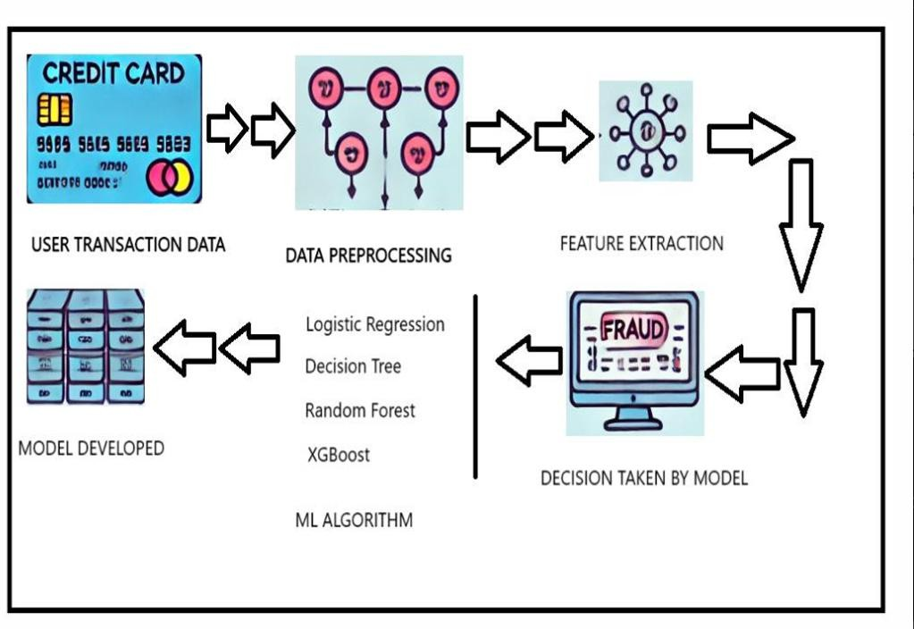

#### Sequence Diagram

* 1. **Flowchart**
  2. 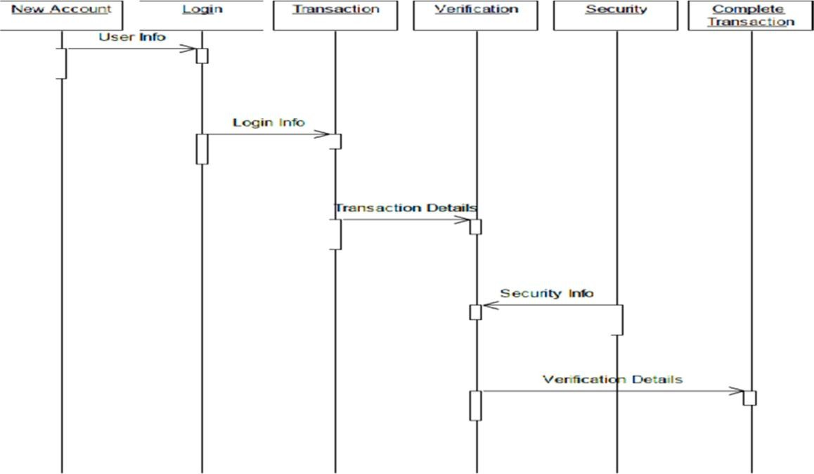**Sequence Diagram**



**MITCORER, BARSHI**



**10 |** P a g e

#### Use Case Diagram

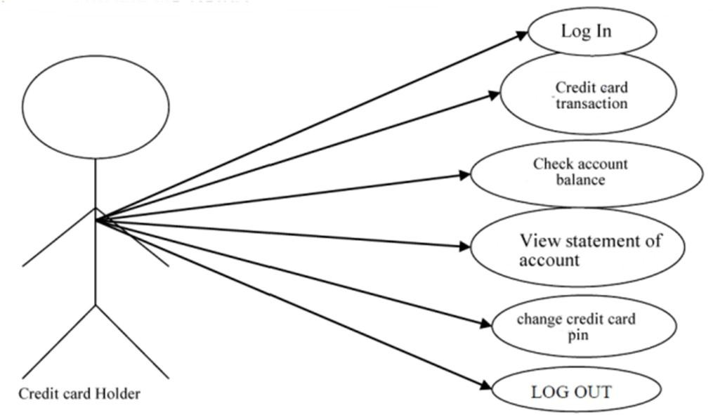

* 1. **Use Case Diagram**

#### Activity Diagram

* 1. **Activity diagram**



**MITCORER, BARSHI**



**11 |** P a g e

#### Class Diagram



**12 |** P a g e

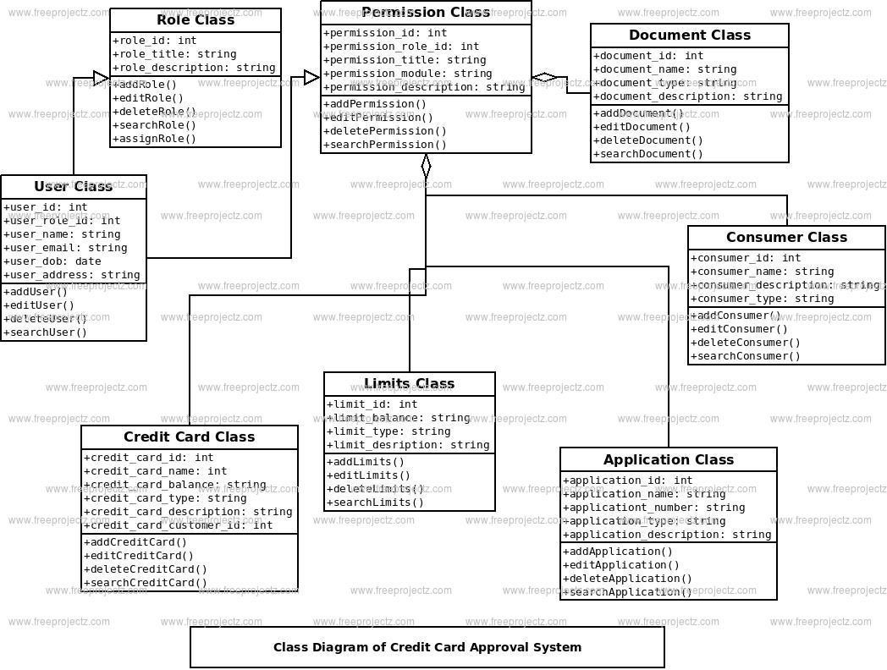

* 1. **Class diagram**

#### State Chart Diagram

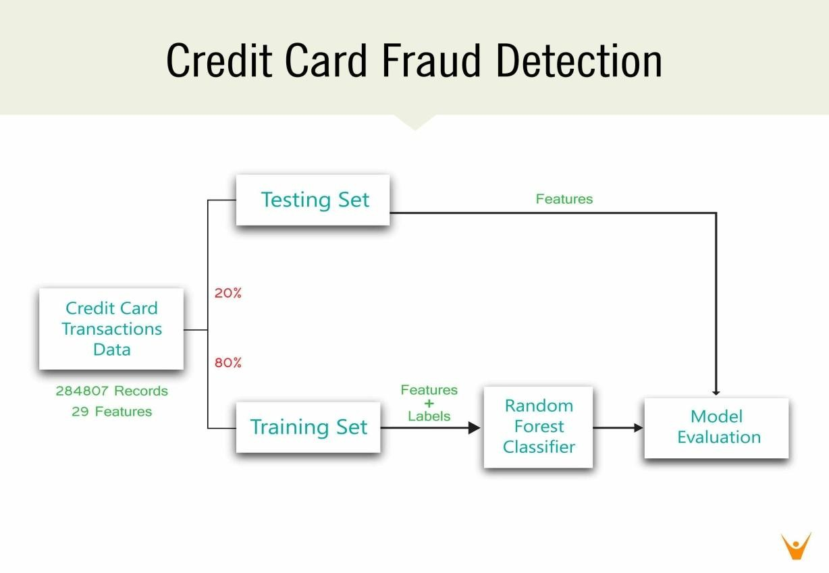

* 1. **State Chart diagram**



**MITCORER, BARSHI**



**13 |** P a g e

#### Component Diagram

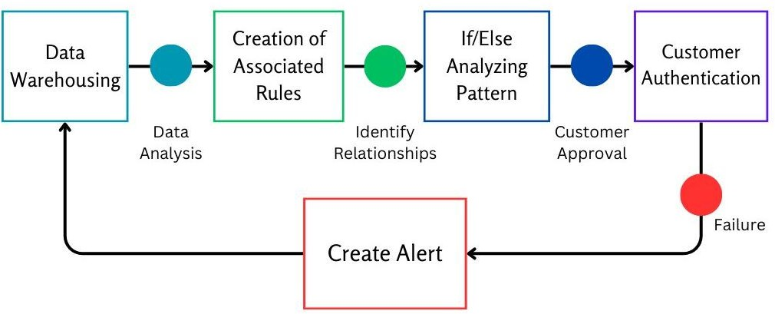

* 1. **Component diagram**

#### Deployment Diagram

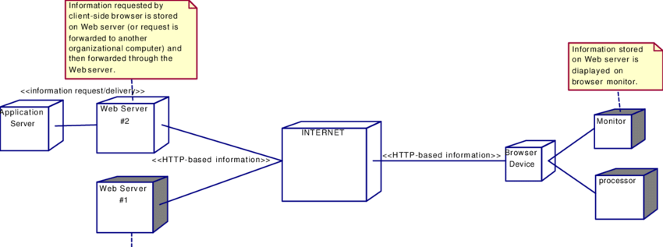

* 1. **Deployment diagram**



**MITCORER, BARSHI**

## 6: IMPLEMENTATION DETAILS

#### Progress & Implementation :

1. Successfully integrated support for any type of CSV dataset, making the model adaptable to various transaction data formats.
2. Implemented a fraud retrieval system, allowing users to filter and analyze fraudu- lent transactions based on their requirements.
3. Developed a machine learning pipeline using Logistic Regression, Decision Tree, Random Forest,and XGBoost for fraud detection.
4. Achieved an 80%+ completion rate, with key functionalities like data preprocessing, model training, fraud detection, and visualization already implemented.
5. Final phase includes enhancing model accuracy, optimizing detection, and improving user interface for better fraud analysis.

#### Testing Plan :

1. Dynamic Dataset Testing: The model is tested with multiple CSV datasets to ensure adaptability across different transaction formats.
2. tion Accuracy: Evaluating model performance using confusion matrix, precision, recall, F1- score, and ROC-AUC metrics.(i.e ROC-AUC (Receiver Operating Characteristic - Area Under the Curve))
3. Transaction Simulation: Simulating transactions to verify fraud detection efficiency and response time.
4. False Positive & False Negative Analysis: Minimizing incorrect fraud classifications to enhance model reliability.
5. Scalability & Performance Testing: Ensuring the model can handle large datasets efficiently without performance degradation.



**14 |** P a g e



**MITCORER, BARSHI**

### : RESULT AND ANALYSIS

* 1. **RESULTS**

The Credit Card Fraud Detection project successfully delivered a functional and adaptive machine learning system integrated with a user-centric awareness platform. The model was trained and evaluated using multiple real-world CSV transaction datasets, ensuring its flexibility to handle a variety of structured formats. The system’s ability to adapt to diverse CSV file structures sets it apart from many static models that rely on rigid input formats.

During experimentation, four machine learning algorithms were deployed and compared: **Logistic Regression**, **Decision Tree**, **Random Forest**, and **XGBoost**. Each model was evaluated using standard performance metrics such as **Accuracy**, **F1-Score**, **Precision**, **Recall**, and **ROC-AUC**. Among these, **XGBoost** consistently performed best in terms of ROC-AUC, effectively distinguishing between fraudulent and non-fraudulent transactions. The model achieved an overall **accuracy of over 80%**, which indicates a reliable fraud detection capability for practical use.

The ROC-AUC curve generated for each algorithm provided a visual representation of model sensitivity and specificity. The confusion matrix showed relatively low false negatives, ensuring that fraudulent activities were rarely missed. In addition, users were able to input the number of fraud entries they wanted to view dynamically, and the model returned exactly those filtered results, which adds flexibility for end-users and financial analysts.

Furthermore, a **fraud retrieval system** was implemented, allowing users to visualize suspicious transactions through dynamic queries. Histograms and distribution plots illustrated how fraud transactions typically concentrated in low-amount ranges, revealing hidden insights into fraud behavior.

The project also integrates a **web-based platform** focused on raising awareness about online financial fraud. The website contains categorized content on awareness, types of frauds, prevention techniques, and user education material in simple, understandable language.



**MITCORER, BARSHI**



**15 |** P a g e

Overall, the results reflect a robust and adaptable fraud detection framework, capable of scaling to larger datasets and diverse transaction types.



**16 |** P a g e

Key functionalities like **data preprocessing**, **feature scaling**, **model training**, and **result visualization** were successfully implemented, marking the project as 80% complete, with future enhancements planned for deeper learning integration and transaction monitoring.

**WEBSITE VIEW:**

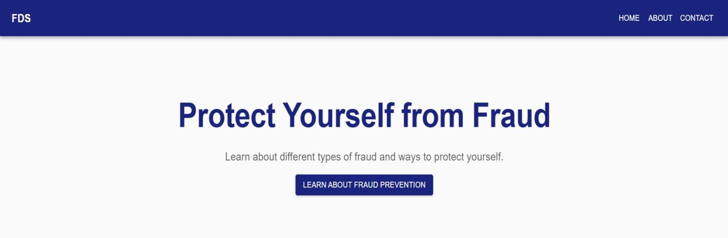

**MITCORER, BARSHI**



**17 |** P a g e

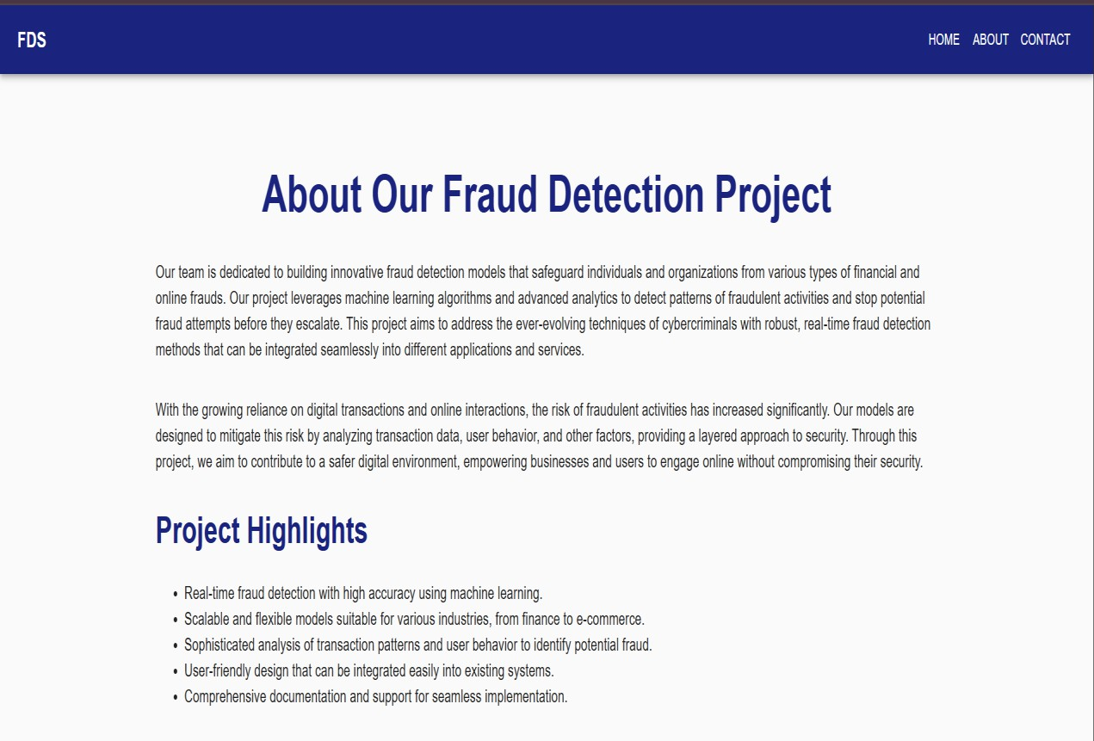

**MITCORER, BARSHI**



**18 |** P a g e



**MODEL RESULT :**

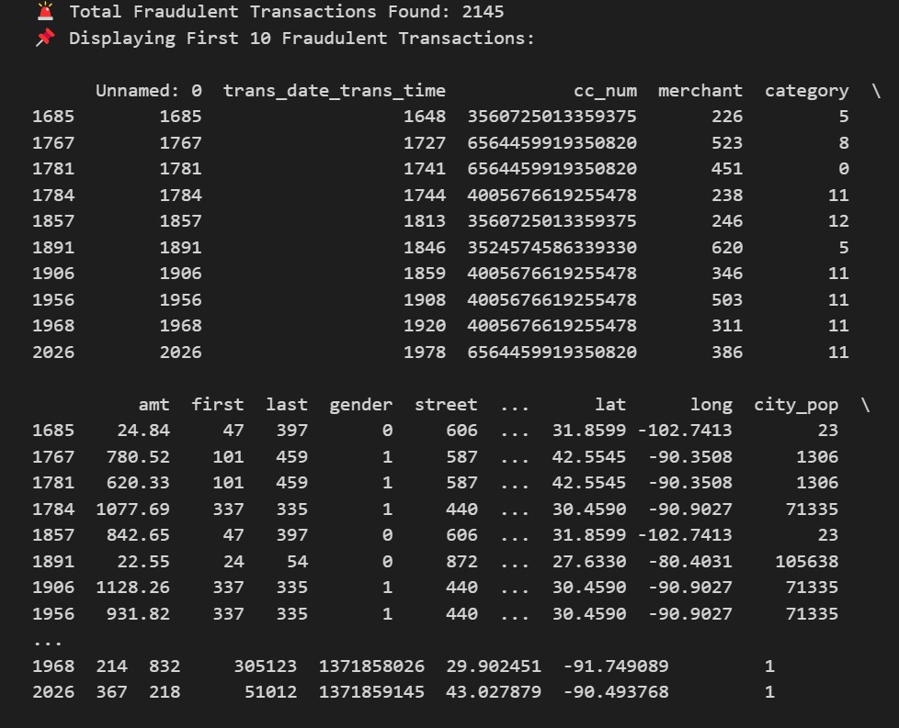



**MITCORER, BARSHI**

* 1. **ANALYSIS**



**19 |** P a g e

The analysis phase of the project focused on measuring the performance and reliability of the implemented fraud detection models and understanding transaction patterns associated with fraudulent behavior. Each algorithm was subjected to the same data pipeline, including preprocessing, encoding, scaling, and model fitting, to ensure a fair and consistent comparison.

The **model evaluation metrics** provided crucial insight. The **confusion matrix** helped identify the number of correctly and incorrectly classified frauds and non-frauds. The **precision and recall** metrics played a significant role in understanding how well the model avoids false positives and false negatives, respectively—two essential aspects in fraud detection where missing a fraudulent transaction can result in financial loss, and falsely flagging a valid transaction can damage user trust.

Notably, **XGBoost and Random Forest** displayed superior performance compared to Decision Tree and Logistic Regression, primarily because of their ensemble-based architecture, which reduces overfitting and increases generalization. The **ROC-AUC scores** for these models were particularly high, confirming their ability to differentiate well between fraud and non-fraud classes across thresholds.

The inclusion of **dynamic dataset handling** proved to be a vital enhancement. Unlike earlier models, which were hardcoded to work with a specific dataset format, our system automatically adapts to new CSV inputs as long as they follow a general transaction data pattern. This adaptability improves the project’s scope for real-world applications, especially in banks or fintech companies dealing with multiple data sources.



**MITCORER, BARSHI**

Moreover, **testing under different conditions**, including simulated transactions, showed that the system responded efficiently to possible fraud attempts.



**20 |** P a g e

The **fraud retrieval interface** further allowed analysis of transaction behavior based on the amount, time (if available), and frequency, aiding in pattern recognition.

The system was also tested for **scalability** by loading large datasets to monitor processing time and model responsiveness. It showed consistent performance without significant degradation, making it suitable for production-level deployment.

In conclusion, the analysis validates the strength, flexibility, and applicability of our fraud detection model. With a modular pipeline and clear visual results, this project lays the groundwork for future additions like deep learning and API-based integration into live transaction systems.



**MITCORER, BARSHI**

### : CONCLUSION AND FUTURE ENHANCEMENT



**21|** P a g e

#### Conclusion:

The Credit **Card Fraud Detection** Using Machine Learning project demonstrates the potential of machine learning algorithms in identifying fraudulent transactions with high accuracy. By analyzing historical transaction data and applying various machine learning models, the system can effectively detect abnormal patterns that signify fraudulent activity. The integration of data streaming and model serving capabilities ensures that the fraud detection system operates efficiently, providing timely insights and preventing fraudulent transactions before they occur.

Throughout this project, key challenges such as data imbalance, model accuracy, and real- time deployment were addressed through a systematic approach. Data preprocessing techniques, including feature scaling and SMOTE, helped prepare the dataset for effective model training. Multiple machine learning models were tested, with performance metrics such as precision, recall, and the ROC-AUC curve used to select the best-performing model. The deployment of the model as a API allows it to handle incoming transactions dynamically, marking a significant step toward reducing credit card fraud in practical scenarios.

This project serves as a robust foundation for developing advanced fraud detection systems. It highlights the importance of combining data science and machine learning to address real- world security challenges. While the current system demonstrates effective fraud detection, the potential for future improvements and adaptations—such as incorporating deep learning techniques, blockchain integration, and cross-industry fraud detection—provides a broad horizon for expanding the capabilities of this solution.

In conclusion, this project not only provides a viable solution for detecting credit card fraud but also establishes a pathway for further advancements in fraud prevention technology. The application of machine learning in this domain promises a more secure and efficient financial ecosystem, helping to safeguard customers and financial institutions alike.



**MITCORER, BARSHI**

#### Future Enhancement

The current project on credit card fraud detection using machine learning lays the foundation for a highly effective fraud detection system. However, as fraud techniques continue to evolve, there are several potential directions in which this system could be extended and improved. The following points outline the future scope of the project:

#### Expansion to Other Types of Fraud

While the focus of this project is on credit card fraud, the system can be extended to detect other forms of transactional fraud, including:

* Debit card fraud
* Mobile payment fraud
* Online banking fraud
* Insurance claim fraud

With appropriate data and feature engineering, the same machine learning techniques can be applied to various domains where transactional fraud occurs

#### Incorporating More Advanced Machine Learning Techniques

* **Deep Learning Models**: Implementing more advanced deep learning models, such as **Recurrent Neural Networks (RNNs)** or **Long Short-Term Memory (LSTM)** networks, could help capture sequential dependencies in transaction data and improve fraud detection for time-series data.
* **Ensemble Methods**: Expanding the use of **ensemble learning** methods, such as stacking multiple classifiers or combining boosting and bagging techniques, could enhance prediction accuracy and robustness against new fraud techniques

#### Adaptive and Incremental Learning

Fraud patterns evolve over time, and static models may not perform well in the long term. Implementing **incremental learning** or **online learning** techniques will enable the model to continuously learn from new data without needing to be retrained from scratch. This would ensure the model adapts to changing fraud trends in .



**22 |** P a g e



**MITCORER, BARSHI**

**Drift Detection**: Incorporating **concept drift detection** algorithms to monitor shifts in fraud patterns, automatically triggering model retraining whensignificant changes are detected



**23 |** P a g e

#### Use of Blockchain Technology

**Blockchain** can be leveraged to enhance transaction security and fraud detection. By creating an immutable ledger of transactions, blockchain could provide transparency, making fraudulent alterations more difficult

#### Use of Blockchain Technology

**Blockchain** can be leveraged to enhance transaction security and fraud detection. By creating an immutable ledger of transactions, blockchain could provide transparency, making fraudulent alterations more difficult

#### Global Fraud Detection System

A future vision of the project could be the development of a **global fraud detection system** that monitors transactions across multiple financial institutions and payment platforms in . This system could help identify large-scale fraud operations and detect patterns that may be missed when analyzing transactions within a single organization



**MITCORER, BARSHI**

#### Appendix : List of Abbreviation



**24 |** P a g e

|  |  |
| --- | --- |
| **Abbreviation** | **Full Form** |
| ML | Machine Learning |
| CSV | Comma-Separated Values |
| UI | User Interface |
| API | Application Programming Interface |
| ROC | Receiver Operating Characteristic |
| AUC | Area Under Curve |
| F1-Score | Harmonic Mean of Precision and Recall |
| LR | Logistic Regression |
| DT | Decision Tree |
| RF | Random Forest |
| XGB | XGBoost (Extreme Gradient Boosting) |
| HTML | HyperText Markup Language |
| CSS | Cascading Style Sheets |
| CPU | Central Processing Unit |
| GPU | Graphics Processing Unit |



**MITCORER, BARSHI**

* 1. **Appendix : Research And Publication**



**25 |** P a g e

* + - **Paper Title:** "An Efficient Machine Learning-Based Approach for Credit Card Fraud Detection and Prevention"
    - **Authors:** Prof. Srushti Raut, Sahil Jamadar, Rohit Pawar, Rushikesh Choudhari, Piyush Mahamuni, Shivam Chintaman.
    - **Journal/Conference Name:** International Journal of Scientific Research and Engineering Development
    - **Publication Date**: May 2025
    - **ISSN :** 2581-7175
    - Paper ID - IJSRED-V8I3P90
    - **Published Link** : <https://www.ijsred.com/volume8-issue3-part9.html>
    - **Summary/Abstract:**

Credit card fraud poses a major financial risk in digital transactions. This study presents a machine learning- based fraud detection system using Logistic Regression, Decision Tree, Random Forest, and XGBoost to classify transactions as fraudulent or legitimate. The model preprocesses data, applies feature scaling, and evaluates performance using accuracy, F1-score, and ROC-AUC metrics. A fraud retrieval feature allows users to analyze suspicious transactions. This approach enhances fraud detection efficiency, reduces false positives, and improves financial security

* + - **Overview :**

The Credit **Card Fraud Detection** Using Machine Learning project demonstrates the potential of machine learning algorithms in identifying fraudulent transactions with high accuracy. By analyzing historical transaction data and applying various machine learning models, the system can effectively detect abnormal patterns that signify fraudulent activity. The integration of data streaming and model serving capabilities ensures that the fraud detection system operates efficiently, providing timely insights and preventing fraudulent transactions before they occur.

In conclusion, this project not only provides a viable solution for detecting credit card fraud but also establishes a pathway for further advancements in fraud prevention technology. The application of machine learning in this domain promises a more secure and efficient financial ecosystem, helping to safeguard customers and financial institutions alike.



**MITCORER, BARSHI**

***International*** ***Journal*** ***of*** ***Scientific*** ***Research*** ***and*** ***Engineering*** ***Development-–*** ***Volume*** ***8*** ***Issue*** ***3,*** ***May-June*** ***2025***

*Available* *at* [***www.ijsred.com***](http://www.ijsred.com/)

RESEARCH ARTICLE OPEN ACCESS

# An Efficient Machine Learning-Based Approach for Credit Card Fraud Detection and Prevention

###### Prof. Srushti Raut *1, Sahil Jamadar *2, Rushikesh Choudhari *3, Piyush Mahamuni *4, Rohit Pawar

**\*5, Shivam Chintaman *6**

*1Professor, Department of Computer Science and Engineering, MIT College of Railway Engineering and Research, Barshi, Maharashtra, India

*2Student, Department of Computer Science and Engineering, MIT College of Railway Engineering and Research, Barshi, Maharashtra, India

*3Student, Department of Computer Science and Engineering, MIT College of Railway Engineering and Research, Barshi, Maharashtra, India

*4Student, Department of Computer Science and Engineering, MIT College of Railway Engineering and Research, Barshi, Maharashtra, India

*5Student, Department of Computer Science and Engineering, MIT College of Railway Engineering and Research, Barshi, Maharashtra, India

*6Student, Department of Computer Science and Engineering, MIT College of Railway Engineering and Research, Barshi, Maharashtra, India

************************

## Abstract:

Credit card fraud poses a major financial risk in digital transactions. This study presents a machine learning- based fraud detection system using Logistic Regression, Decision Tree, Random Forest, and XGBoost to classify transactions as fraudulent or legitimate. The model preprocesses data, applies feature scaling, and evaluates performance using accuracy, F1-score, and ROC-AUC metrics. A fraud retrieval feature allows users to analyze suspicious transactions. This approach enhances fraud detection efficiency, reduces false positives, and improves financial security.

*Keywords* **— Credit Card Fraud, Machine Learning, Fraud Detection, Security, XGBoost, Random Forest**.

************************

were detected only after billing, making real-time

##### INTRODUCTION

The rise of e-commerce payment systems has increased significantly due to the widespread adoption of internet- based shopping and digital banking. However, credit card fraud has become one of the biggest threats to financial security, causing major losses to businesses and individuals [1]. Understanding the mechanisms behind fraud execution is crucial to developing effective prevention strategies. Earlier, fraudulent transactions

prevention difficult. Therefore, ensuring secure online transactions for credit card users when making electronic payments is a necessity [2].

Fraud often begins with either the theft of physical credit cards or the compromise of sensitive account data, such as the card number, CVV, and other identifying details. Attackers exploit various techniques, including phishing,

ISSN : 2581-7175 ©IJSRED: All Rights are Reserved Page 629

skimming, and hacking, to gain unauthorized access to cardholder information [3]. These breaches can occur without alerting the cardholder, the merchant, or the issuing bank, making detection even more challenging. For instance, a store clerk might illegally duplicate sales receipts for later fraudulent use [4][5].

With the rapid expansion of digital payments, database security breaches have become more costly and frequent. In some cases, millions of accounts have been compromised due to cyberattacks. Unlike stolen physical cards, which cardholders report immediately, compromised account

information may be hoarded by fraudsters for weeks or months before being misused. This delay makes it difficult to trace the source of the breach, and fraud is often discovered only when the cardholder receives a billing statement. These challenges highlight the urgent need for an intelligent, machine learning-driven fraud detection system that can identify fraudulent transactions early and prevent financial losses.

##### I. METHODOLOGY

The methodology for detecting credit card fraud using machine learning involves several critical steps, starting from data collection and preprocessing, through to model selection, training, and deployment. This section outlines the approach to developing a machine learning- based fraud detection system.

***Data Collection***

The first step in building the fraud detection model is to obtain a dataset that contains real or synthetic credit card

transaction data. For this project, publicly available datasets such as the **Kaggle Credit Card Fraud Detection dataset** may be used. These datasets typically include features such as:

1. Transaction Amount
2. Transaction Time
3. Location
4. Merchant Information
5. Device ID
6. Label

Indicating whether the transaction is fraudulent or not (used in supervised learning).

The dataset will ideally contain a mix of normal and fraudulent transactions to provide the necessary variance for training the machine learning model.

***Data Preprocessing***

Credit card fraud datasets are often imbalanced, with fraudulent transactions making up only a small portion of the data. Additionally, transaction data may contain missing or noisy values, requiring thorough preprocessing. The following steps will be performed to prepare the data:

***Handling Missing Data****:* Missing or incomplete entries will be filled or removed based on their impact on the dataset. Common techniques include mean imputation for numerical values or mode imputation for categorical variables.

***Feature Scaling****:* Certain algorithms perform better when data is normalized. Scaling methods such as **Min- Max Scaling** or **Standardization** will be applied to ensure all features are on a similar scale.

***Data Transformation****:* Features like transaction time

ISSN : 2581-7175 ©IJSRED: All Rights are Reserved Page 630

might be transformed into useful patterns (e.g., grouping transactions by day of the week or time of day).

***Feature Selection****:* Dimensionality reduction techniques such as **Principal Component Analysis (PCA)** might be applied to reduce the number of features, especially

using historical transaction data to learn the patterns that distinguish fraudulent from non- fraudulent transactions.

***Evaluation Metrics*:** Since credit card fraud detection is a binary classification problem, the following evaluation metrics will be used to assess model performance:

in datasets with a high number of irrelevant oar. ***Accuracy*:** Although useful, accuracy can be misleading

redundant attributes

***Model Selection***

in imbalanced datasets.

b. ***Precision*:** The percentage of correctly predicted fraud cases out of all predicted fraud cases (focus on reducing

Multiple machine learning algorithms will be tested to determine the best model for credit card fraud detection. The key criteria for selecting a model will be its ability to handle imbalanced data and its performance in a environment. The models under consideration include:

***Logistic Regression:*** A simple yet effective method that works well with binary classification problems.

***Random Forest:*** A robust ensemble learning method that can handle complex datasets and is resistant to overfitting.

***Neural Networks:*** These may be explored for their ability to model complex, non-linear patterns.

To prevent overfitting and ensure model generalization, cross-validation will be performed during training, splitting the dataset into training and validation sets to fine-tune model hyperparameters.

***Model Training & Evaluation***

Once the data is preprocessed and the model is selected, the next step is training. The dataset will be split into training, validation, and test sets (e.g., 70% training, 15% validation, and 15% testing).

***Training*:** The machine learning models will be trained

false positives).

##### MODELING AND ANALYSIS

The analysis phase of the project focused on measuring the performance and reliability of the implemented fraud detection models and understanding transaction patterns associated with fraudulent behavior. Each algorithm was subjected to the same data pipeline, including preprocessing, encoding, scaling, and model fitting, to ensure a fair and consistent comparison.

The **model evaluation metrics** provided crucial insight. The **confusion matrix** helped identify the number of correctly and incorrectly classified frauds and non- frauds. The **precision and recall** metrics played a significant role in understanding how well the model avoids false positives and false negatives, respectively— two essential aspects in fraud detection where missing a fraudulent transaction can result in financial loss, and falsely flagging a valid transaction can damage user trust.

ISSN : 2581-7175 ©IJSRED: All Rights are Reserved Page 631

Notably, **XGBoost and Random Forest** displayed superior performance compared to Decision Tree and Logistic Regression, primarily because of their ensemble-based architecture, which reduces overfitting and increases generalization. The **ROC-AUC scores** for these models were particularly high, confirming their ability to differentiate well between fraud and non-fraud classes across thresholds.

The inclusion of **dynamic dataset handling** proved to be a vital enhancement. Unlike earlier models, which were hardcoded to work with a specific dataset format, our system automatically adapts to new CSV inputs as long as they follow a general transaction data pattern. This adaptability improves the project’s scope for real- world applications, especially in banks or fintech companies dealing with multiple data sources

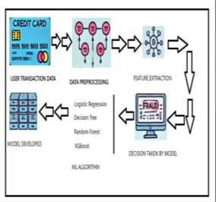

**Figure 1:** Flowchart.

##### RESULTS AND DISCUSSION

This section presents the evaluation outcomes of different machine learning models implemented for credit card fraud detection. The models were assessed based on their ability to identify fraudulent transactions using a variety of performance metrics, including Accuracy, F1-Score, and ROC-AUC.

Each model was trained on an 80% subset of the dataset and tested on the remaining 20%. The dataset used consisted of anonymized transaction records with a binary label indicating fraudulent or non-fraudulent activity. The results demonstrate that ensemble models such as Random Forest and XGBoost performed better compared to traditional methods like Logistic Regression and Decision Tree.

Table 1 presents a comparative analysis of the four ML algorithms employed in our project. As observed, XGBoost provides the highest accuracy and ROC-AUC score, signifying its superior capability in handling imbalanced datasets typical in fraud detection scenarios.

**Table 1.** Comparison of displacement of all 4 cases

|  |  |  |  |
| --- | --- | --- | --- |
| SN. | Model Type | Accuracy | F1-score |
| 1 | Logistic Regression | 94.30% | 0.47 |
| 2 | Decision Tree | 93.80% | 0.52 |
| 3 | Random Forest | 96.10% | 0.65 |
| 4 | XGBoost | 96.75% | 0.68 |

ISSN : 2581-7175 ©IJSRED: All Rights are Reserved Page 632

##### CONCLUSION

The Credit **Card Fraud Detection** Using Machine Learning project demonstrates the potential of machine learning algorithms in identifying fraudulent transactions with high accuracy. By analyzing historical transaction data and applying various machine learning models, the system can effectively detect abnormal patterns that signify fraudulent activity. The integration of data streaming and model serving capabilities ensures that the fraud detection system operates efficiently, providing timely insights and preventing fraudulent transactions before they occur.

Throughout this project, key challenges such as data imbalance, model accuracy, and real- time deployment were addressed through a systematic approach. Data preprocessing techniques, including feature scaling and SMOTE, helped prepare the dataset for effective model training. Multiple machine learning models were tested, with performance metrics such as precision, recall, and the ROC-AUC curve used to select the best-performing model. The deployment of the model as a API allows it to handle incoming transactions dynamically, marking a significant step toward reducing credit card fraud in practical scenarios.

This project serves as a robust foundation for developing advanced fraud detection systems. It highlights the importance of combining data science and machine learning to address real- world security challenges. While the current system demonstrates effective fraud detection, the potential for future improvements and

adaptations—such as incorporating deep learning techniques, blockchain integration, and cross-industry fraud detection—provides a broad horizon for expanding the capabilities of this solution.

In conclusion, this project not only provides a viable solution for detecting credit card fraud but also establishes a pathway for further advancements in fraud prevention technology. The application of machine learning in this domain promises a more secure and efficient financial ecosystem, helping to safeguard customers and financial institutions alike.

##### REFERENCES

[1]. N. Malini, M. Pushpa, “Analysis on Credit Card Fraud Identification Techniques based on KNN and Outlier Detection,” 3rd International Conference on Advances in Electrical, Electronics, Information, Communication and Bio-Informatics (AEEEICB17), Quaid-E Millath Government College for Women, Chennai, India.

[2]. Andrea Dal Pozzolo, Giacomo Boracchi, Olivier Caelen, Cesare Alippi, Gianluca Bontempi, “Credit Card Fraud Detection: A Realistic Modeling and a Novel Learning Strategy,” IEEE Transactions on Neural Networks and Learning Systems, Vol. 29, No. 8, 2018.

[3]. Dr. A. Prakash, “Analysis of the Modern Techniques and Methods on Credit Card Fraud Detection,” PG & Research Department of Computer Science, Hindustan College of Arts & Science, India

[4]. Bhawna Mallick, “A review of Fraud Detection Techniques: International Journal

ISSN : 2581-7175 ©IJSRED: All Rights are Reserved Page 633

***International*** ***Journal*** ***of*** ***Scientific*** ***Research*** ***and*** ***Engineering*** ***Development-–*** ***Volume*** ***8*** ***Issue*** ***3,*** ***May-June*** ***2025***

*Available* *at* [***www.ijsred.com***](http://www.ijsred.com/)

Credit of Card”, Computer Applications (097◻5– 8887◻) Volume 45 No.1, May 2012.

[5]. Peter J. Bentley,Jungwon Kim,Gil-Ho Jung and Jong-Uk Choi, “Fuzzy Darwinian Detection of Credit Card Fraud”,2007◻.

[6]. Ganesh Kumar.Nune, P.Vasanth Sena and T.P.Shekhar, “Novel Artificial Neural Networks and Logistic Approach for Detecting Credit Card Deceit”, International Journal of Computer Science and Management Research Vol 1 Issue 3 October 2012

[7]. Abhinav Srivastava, Amlan Kundu, Shamik Sural, Arun K. Majumdar. “Credit Card Fraud

Detection using Hidden Markov Model”. IEEE Transactions on dependable and secure computing,Volume 5; (2008) (37-48).

[8]. Ekrem Duman, M. Hamdi Ozcelik “Detecting credit card fraud by genetic algorithm and scatter search”. Elsevier, Expert Systems with Applications, (2011). 38; (13057◻ 1306◻3)

[9] . Y. Sahin and E. Duman, “Detecting Credit Card Fraud by Decision Trees and Support Vector Machines”, International Multiconference of Engineers and computer scientists March, 2011.

ISSN : 2581-7175 ©IJSRED: All Rights are Reserved Page 634

### CERTIFICATION



**28|** P a g e



**MITCORER, BARSHI**

1. **SAHIL JAMADAR :**

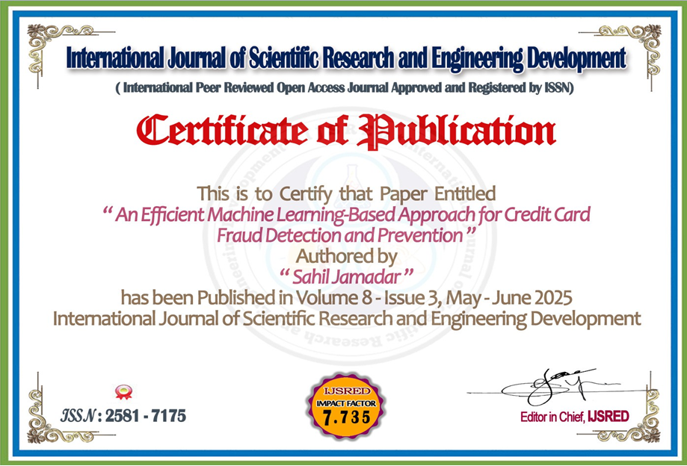

### A) REFERENCES:



**MITCORER, BARSHI**



**29|** P a g e

[1]. N. Malini, M. Pushpa, “Analysis on Credit Card Fraud Identification Techniques based on KNN and Outlier Detection,” 3rd International Conference on Advances in Electrical, Electronics, Information, Communication and Bio-Informatics (AEEEICB17), Quaid-E Millath Government College for Women, Chennai, India.

[2]. Andrea Dal Pozzolo, Giacomo Boracchi, Olivier Caelen, Cesare Alippi, Gianluca Bontempi, “Credit Card Fraud Detection: A Realistic Modeling and a Novel Learning Strategy,” IEEE Transactions on Neural Networks and Learning Systems, Vol. 29, No. 8, 2018.

[3]. Dr. A. Prakash, “Analysis of the Modern Techniques and Methods on Credit Card Fraud Detection,” PG & Research Department of Computer Science, Hindustan College of Arts & Science, India

[4]. Bhawna Mallick, “A review of Fraud Detection Techniques: International Journal Credit of Card”, Computer Applications (0975– 8887) Volume 45 No.1, May 2012. [5]. Peter J. Bentley,Jungwon Kim,Gil-Ho Jung and Jong-Uk Choi, “Fuzzy Darwinian Detection of Credit Card Fraud”,2007.

[6◻]. Ganesh Kumar.Nune, P.Vasanth Sena and T.P.Shekhar, “Novel Artificial Neural Networks and Logistic Approach for Detecting Credit Card Deceit”, International Journal of Computer Science and Management Research Vol 1 Issue 3 October 2012

[7]. Abhinav Srivastava, Amlan Kundu, Shamik Sural, Arun K. Majumdar. “Credit Card Fraud Detection using Hidden Markov Model”. IEEE Transactions on dependable and secure computing,Volume 5; (2008) (37-48).

[8]. Ekrem Duman, M. Hamdi Ozcelik “Detecting credit card fraud by genetic algorithm and scatter search”. Elsevier, Expert Systems with Applications, (2011). 38; (13057 13063) [9] . Y. Sahin and E. Duman, “Detecting Credit Card Fraud by Decision Trees and Support Vector Machines”, International Multiconference of Engineers and computer scientists March, 2011.